

**Mined Systems Inc.**

**Metrics Intelligence ©**

# 

**SOW 3A, v3 Design Document, Release 12.8**

**September 22, 2012**

Table of Contents

1 Update “Companies” Functionality 3

1.1 Update Data Entry User Interface 3

1.2 Update Data Edit User Interface 4

1.3 Update “Upload Company” Functionality 4

1.4 Clarification of “Required” Fields 4

1.5 Update Export to Excel Functionality 4

1.6 Updated Report Functionality 4

2 Update “Contacts” Functionality 5

2.1 Update Data Entry User Interface 5

2.2 Update Data Edit User Interface 6

2.3 Update “Upload Contacts” Functionality 6

2.4 Clarification of “Required” Fields 6

2.5 Update Export to Excel Functionality 6

2.6 Updated Report Functionality 6

3 Update “Pipeline” Functionality 7

3.1 Update Data Entry User Interface 7

3.2 Update Data Edit User Interface 8

3.3 Clarification of “Required” Fields 8

3.4 Update Export to Excel Functionality 8

3.5 Updated Report Functionality 9

4 E-Mail Functionality Update 9

**Requirements**

The following set of requirements will form the basis of SOW 3A, Release 12.8. The functionality described within this SOW is based upon feedback from the initial set of Pilot Users and needs to be incorporated to ensure the Pilot User data are being accurately captured.

This release will be built as an addition to the functionality for the Sandler Application that has been developed under ***SOW #3 Design Document – Release 12.7***. The LOE provided accounts for the development, testing and deployment of the updated requirements and is broken out in each of the sections below.

# Update “Companies” Functionality

## Update Data Entry User Interface

Update the user interface by inserting fields as indicated in the screen shots below. All fields will be NOT REQUIRED and will be text entry fields unless otherwise noted to have “choices”. The new fields are shaded green and identified by the “bracket” symbol:

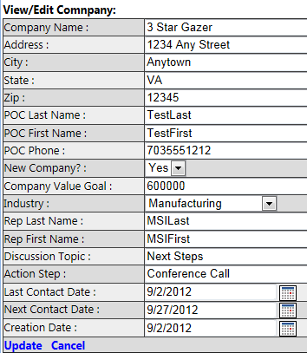 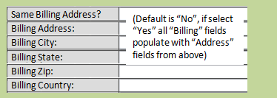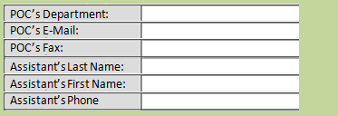

**<<CONTINUED ON NEXT PAGE>>**



## Update Data Edit User Interface

Update the user interface by inserting fields as indicated in the screen shots above. All fields will be text entry fields unless otherwise noted to have “choices”.

## Update “Upload Company” Functionality

Update the “Upload Company” functionality by inserting the fields as indicated in the screen shots above into the data load capability.

## Clarification of “Required” Fields

All fields with the exception of “Company Name” should be NON-REQUIRED fields. This will provide the greatest flexibility for the user community to add only those fields of data that they want to enter and not have to put “dummy” data into erroneously identified “required” fields.

## Update Export to Excel Functionality

Update the export to excel functionality by inserting fields as indicated in the screen shots above. The columns in the spreadsheet should also be in the order that the data are presented in the screen shots above.

## Updated Report Functionality

Based on the updated fields in the screen shots above, there will be NO UPDATES required to any of the Release 12.7 reports.

# Update “Contacts” Functionality

## Update Data Entry User Interface

Update the user interface by inserting fields as indicated in the screen shots below. All fields will be NOT REQUIRED and will be text entry fields unless otherwise noted to have “choices”. The new fields are shaded green and identified by the “bracket” symbol:

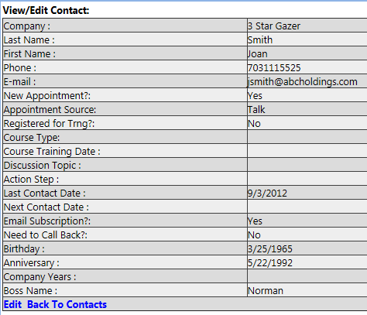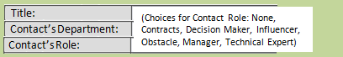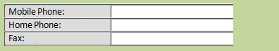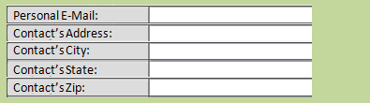

**<<CONTINUED ON NEXT PAGE>>**



## Update Data Edit User Interface

Update the user interface by inserting fields as indicated in the screen shots above. All fields will be text entry fields unless otherwise noted to have “choices”.

## Update “Upload Contacts” Functionality

Update the “Upload Contacts” functionality by inserting the fields as indicated in the screen shots above into the data load capability.

## Clarification of “Required” Fields

All fields with the exception of “Last Name” and “First Name” should be NON-REQUIRED fields. This will provide the greatest flexibility for the user community to add only those fields of data that they want to enter and not have to put “dummy” data into erroneously identified “required” fields.

## Update Export to Excel Functionality

Update the export to excel functionality by inserting fields as indicated in the screen shots above. The columns in the spreadsheet should also be in the order that the data are presented in the screen shots above.

## Updated Report Functionality

Based on the updated fields in the screen shots above, there will be NO UPDATES required to any of the Release 12.7 reports.

# Update “Pipeline” Functionality

## Update Data Entry User Interface

Update the user interface by inserting fields as indicated in the screen shots below. All fields will be NOT REQUIRED and will be text entry fields unless otherwise noted to have “choices”. The new fields are shaded green and identified by the “bracket” symbol:

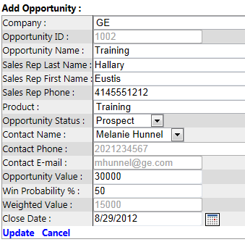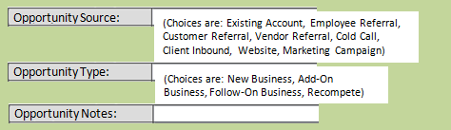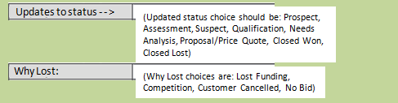

**<<CONTINUED ON NEXT PAGE>>**

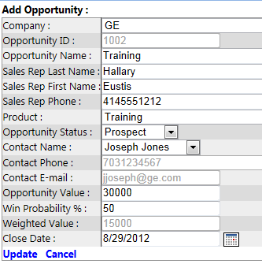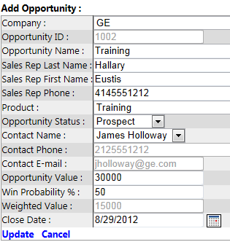

## Update Data Edit User Interface

Update the user interface by inserting fields as indicated in the screen shots above. All fields will be text entry fields unless otherwise noted to have “choices”.

The other SIGNIFICANT UPDATE to the functionality for the “Pipeline” section is the ability to add multiple contacts to a specific opportunity as shown above. The “Add Another Contact” (No/Yes selection) will enable the user to add multiple contacts to the opportunity since there may actually be many people [with different roles] that will be applicable to any specific opportunity. The assumption would be that as more contacts would be added to the opportunity, the data on the screen would continue to populate at the end of the screen and the vertical scroll bars would appear when required.

## Clarification of “Required” Fields

All fields with the exception of “Opportunity Name” should be NON-REQUIRED fields. This will provide the greatest flexibility for the user community to add only those fields of data that they want to enter and not have to put “dummy” data into erroneously identified “required” fields.

## Update Export to Excel Functionality

Update the export to excel functionality by inserting fields as indicated in the screen shots above. The columns in the spreadsheet should also be in the order that the data are presented in the screen shots above.

When additional contacts are added to the same opportunity, we will need to be sure and capture all of those contacts within the “Excel Export” function. These could be additional columns [to support the additional contacts for the “Opportunity” export, or they could be additional rows within the excel file where everything in each of the rows is exactly the same, except the Contact name and information is different. Whichever of these two methods will work best should be used - - as long as the data are provided in the exported excel file.

## Updated Report Functionality

Based on the updated fields in the screen shots above, an update WILL BE REQUIRED for the “New Appointments By Source” report currently in Release 12.7. The new selection types identified in the screen shots above need to be added to the report graphic.

# E-Mail Functionality Update

We need to update the outbound email functionality to enable the users to select users [from a drop down list] and SAVE that selection so that they can send to any of those “saved groups” again in the future. This is basically the functionality of enabling the users to create their own “groups” within the outbound e-mail capability.